Ghana

## GNI per capita and development level

The data set shows the GNI per capita and development level of the country each year.

## # A tibble: 19 x 5  
## country iso3c date GNIperCapita devCategory   
## <chr> <chr> <dbl> <dbl> <chr>   
## 1 Ghana GHA 1996 1593. Lower Middle Income  
## 2 Ghana GHA 1998 1563. Lower Middle Income  
## 3 Ghana GHA 2000 1593. Lower Middle Income  
## 4 Ghana GHA 2002 1593. Lower Middle Income  
## 5 Ghana GHA 2003 1593. Lower Middle Income  
## 6 Ghana GHA 2004 9518. Upper Middle Income  
## 7 Ghana GHA 2005 1692. Lower Middle Income  
## 8 Ghana GHA 2006 1109. Lower Middle Income  
## 9 Ghana GHA 2007 1128. Lower Middle Income  
## 10 Ghana GHA 2008 1202. Lower Middle Income  
## 11 Ghana GHA 2009 1229. Lower Middle Income  
## 12 Ghana GHA 2010 1278. Lower Middle Income  
## 13 Ghana GHA 2011 1401. Lower Middle Income  
## 14 Ghana GHA 2012 1463. Lower Middle Income  
## 15 Ghana GHA 2013 1583. Lower Middle Income  
## 16 Ghana GHA 2014 1573. Lower Middle Income  
## 17 Ghana GHA 2015 1604. Lower Middle Income  
## 18 Ghana GHA 2016 1612. Lower Middle Income  
## 19 Ghana GHA 2017 1691. Lower Middle Income

## GDP growth and economic growth classification

The data set shows the GDP growth and the ecomic growth classification of the country each year.

## # A tibble: 19 x 5  
## country iso3c date GDPannualGrowthRate GDPgrowthCategory4  
## <chr> <chr> <dbl> <dbl> <fct>   
## 1 Ghana GHA 1996 4.60 moderate growth   
## 2 Ghana GHA 1998 4.70 moderate growth   
## 3 Ghana GHA 2000 3.70 moderate growth   
## 4 Ghana GHA 2002 4.50 moderate growth   
## 5 Ghana GHA 2003 5.20 moderate growth   
## 6 Ghana GHA 2004 5.60 fast growth   
## 7 Ghana GHA 2005 5.90 fast growth   
## 8 Ghana GHA 2006 6.40 fast growth   
## 9 Ghana GHA 2007 4.35 moderate growth   
## 10 Ghana GHA 2008 9.15 fast growth   
## 11 Ghana GHA 2009 4.84 moderate growth   
## 12 Ghana GHA 2010 7.90 fast growth   
## 13 Ghana GHA 2011 14.0 fast growth   
## 14 Ghana GHA 2012 9.29 fast growth   
## 15 Ghana GHA 2013 7.31 fast growth   
## 16 Ghana GHA 2014 2.90 moderate growth   
## 17 Ghana GHA 2015 2.18 slow growth   
## 18 Ghana GHA 2016 3.45 moderate growth   
## 19 Ghana GHA 2017 8.14 fast growth

## Development trend

The plot shows the development trend of the country.

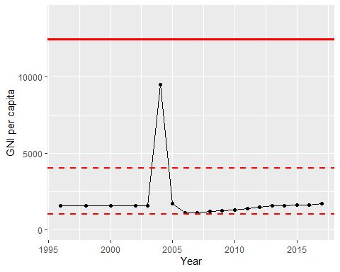

GNI Per Capita Trend